* Q3:

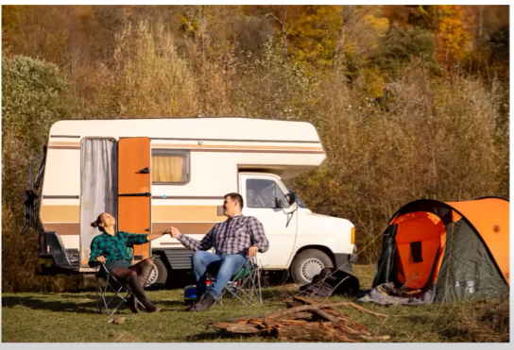

- Answer:

This picture is taken in the forrest.

There are 2 people in the picture.

Both of them are smiling and holding hands.

(They are wearing [plaid shirts] - áo kẻ sọc)

On the left, the woman is wearing a green shirt.

(the woman is looking up the sky)

next to her, the man is looking at her.

Behind them, i can see a car.

* Q4:

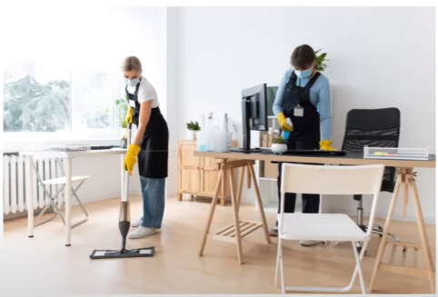

- Answer:

this picture is taken in the office.

there are 2 people in the picture.

both of them are wearing masks.

on the left side, a woman is wearing a white shirt.

she is cleaning the floor.

(she is mopping the floor)

next to her, a woman is wearing a blue shirt.

she is cleaning a table.

(she is wiping the table)

Around them, i can see some chairs and tables.

(On the table, i can see a computer screen)

* Q5:

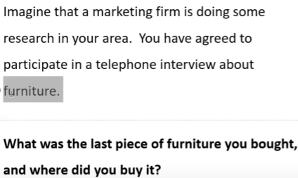

- Answer:

The last piece of furniture i had bought was a table.

I was bought it at a furniture store near my house. (nên nói mua ở gần nhà)

Because i wanted to give it to my father on his birthday.

* Q6:

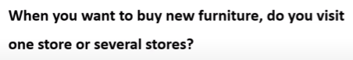

- Answer:

i often visit several stores.

this is because i can compare the price of the furniture in several stores.

And then i can buy the best price.

(This is because it allows me to compare many things such as prices and features.)

* Q7:

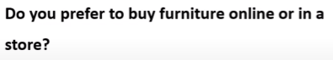

- Answer:

(Chọn nói về ONLINE nhiều hơn)

i prefer to buy furniture online.

First, it is time-saving. I don't need to leave the house.

Second, it helps me save money.

Online stores usually offers customers discounts.

That's why i prefer to buy furniture online.

* Q8:

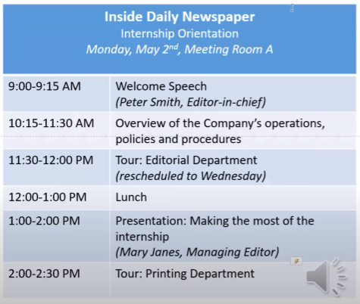

**Question 8:**

**Where will the orientation start and What time will it start?**

- Answer:

It/The orientation will start in the meeting room A.

And it will start at 9AM

* Q9:

**Question 9:**

**I heard that there will be a tour of Tour: Editorial Department during the orientation.**

**Is that right.**

- Answer:

No, you have the wrong information.

This tour/It (The tour of the editorial department) has been rescheduled to Wednesday.

* Q10:

**Question 10:**

**Could you please tell me the section after lunch?**

Answer:

There are 2 sessions after lunch.

The first is A Presentation ON making the most of the internship at 1PM.

It will be led by Mary Janes,The Managing Editor

The second is A tour OF printing department.

It will be led by Ken Thompson, the reporter of the company.

* Q11:

**Question 11:**

**What are some advantages of living in a big city**

- Answer:

There are several advantages of living in a big city.

First, there are many job opportunities.

This is because many companies are located in a big city,

Second, it's good for children.

A big city often has many good schools.

Therefore, children can receive/get a better education.

Take my cousin as example.

She was born and grew up in a small city.

After graduating from college, she had difficult in finding a job.

(She struggled to find a job)

This is because there were few companies in her city.

So that, she decided to move to a big city.

After only a few months here, she was able to get a good job.